8.11; Derive a Mealy-type FSM from the description. Minimize the number of states required and redraw the diagram.

Question:

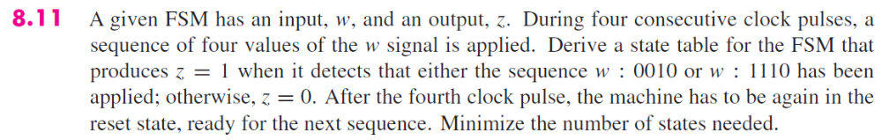

Solution:

8.26; Describe the FSM using behavioural VHDL code.

Question:

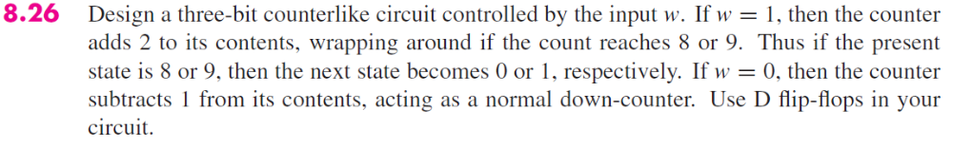

Solution:

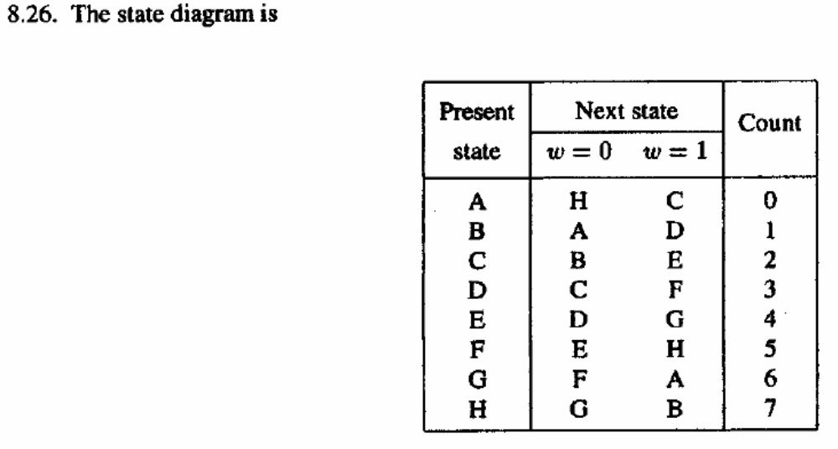
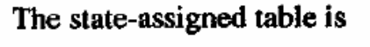
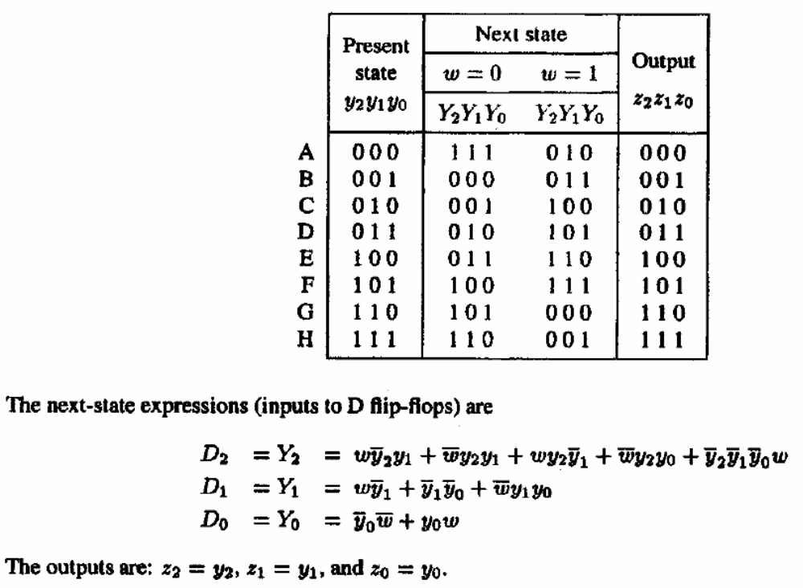

8.29; Assuming tsu = 0.6 ns, tcQ = 0.8 - 1.0 ns, th = 0.4 ns and the delay of a k-input gate is
tk-gate = 1.0 + 0.1k ns, what is the maximum frequency of this cicruit? All other things being equal,
how large would th need to be to have hold time being violated?

Question:

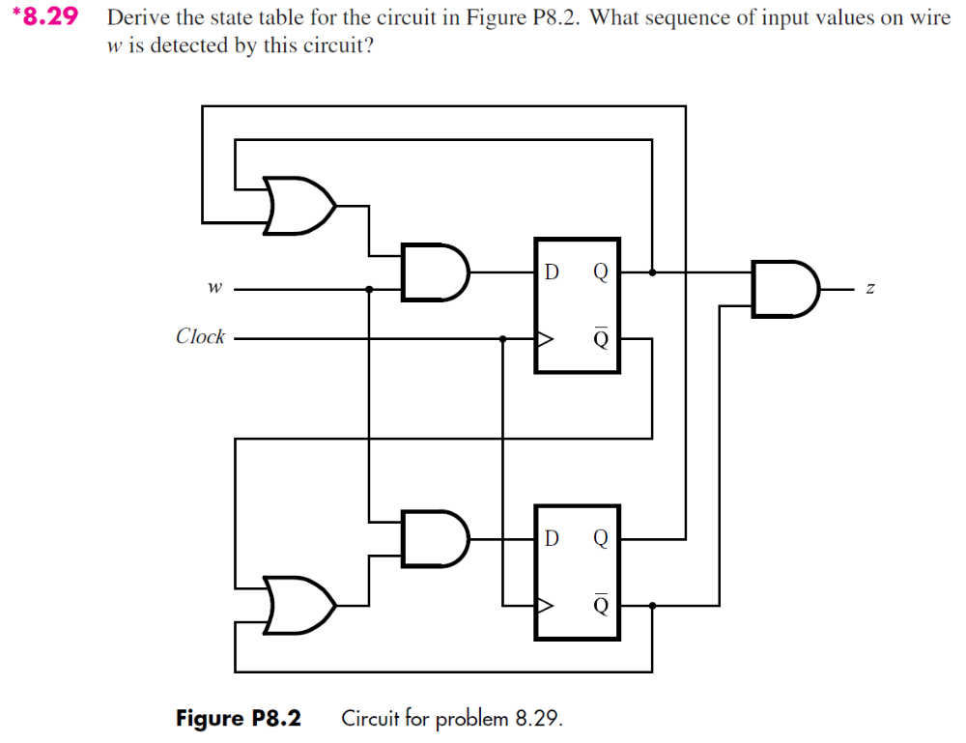

Solution:

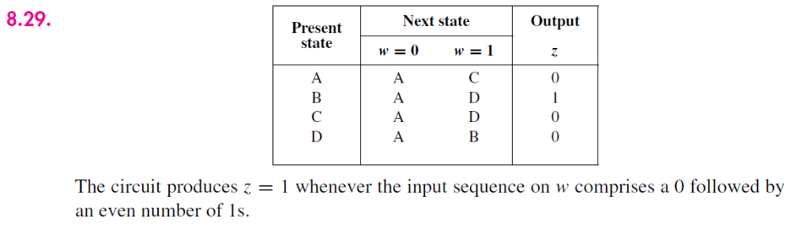

8.8

Question:

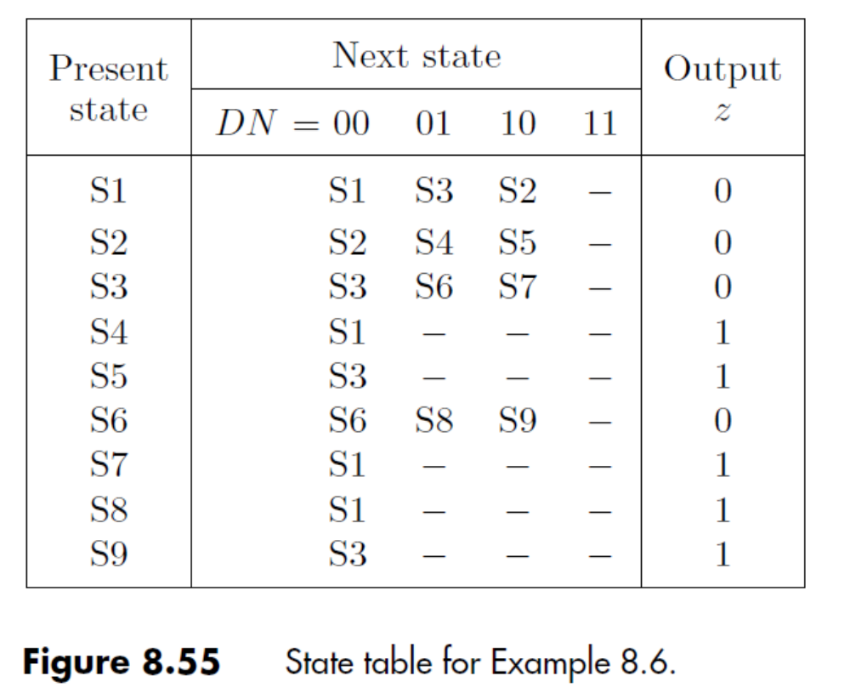

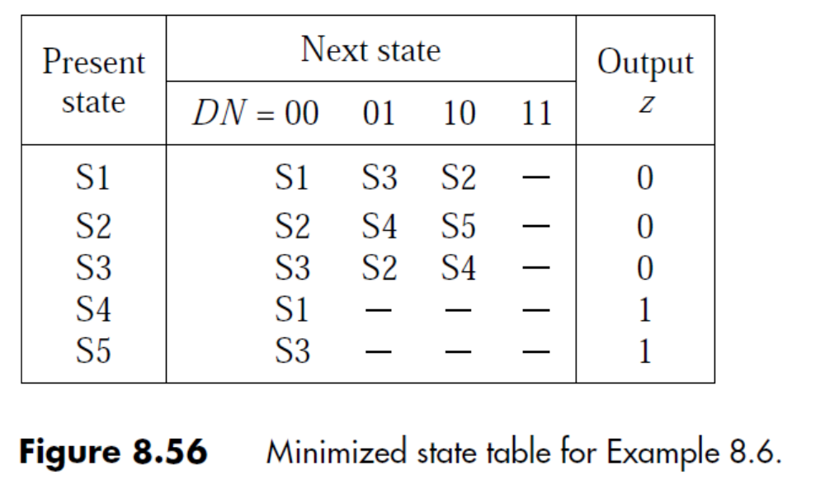

Solution:

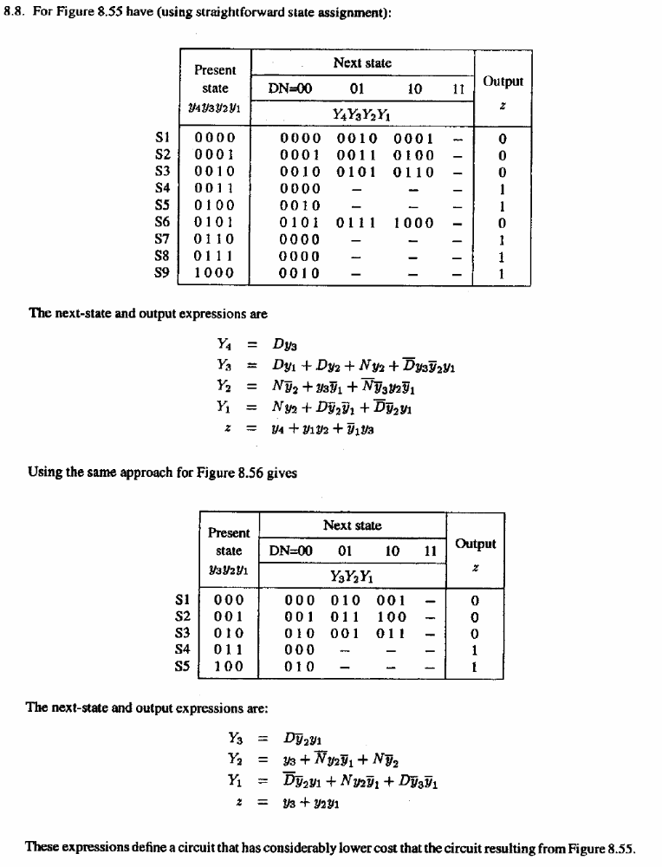

8.19

Question:

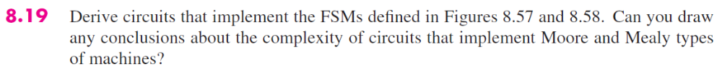

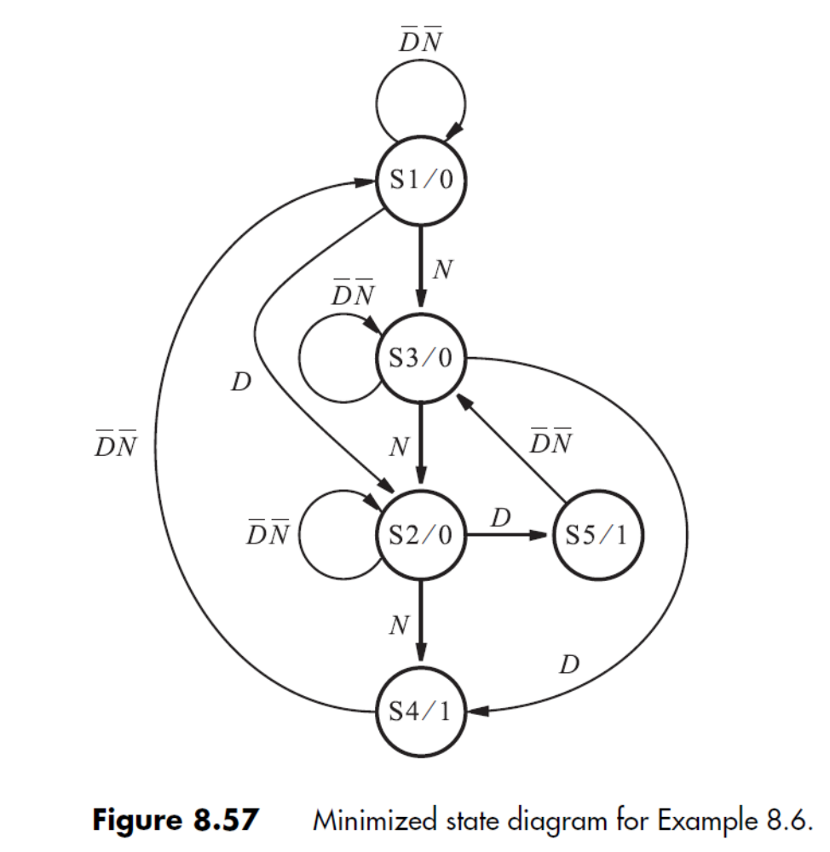

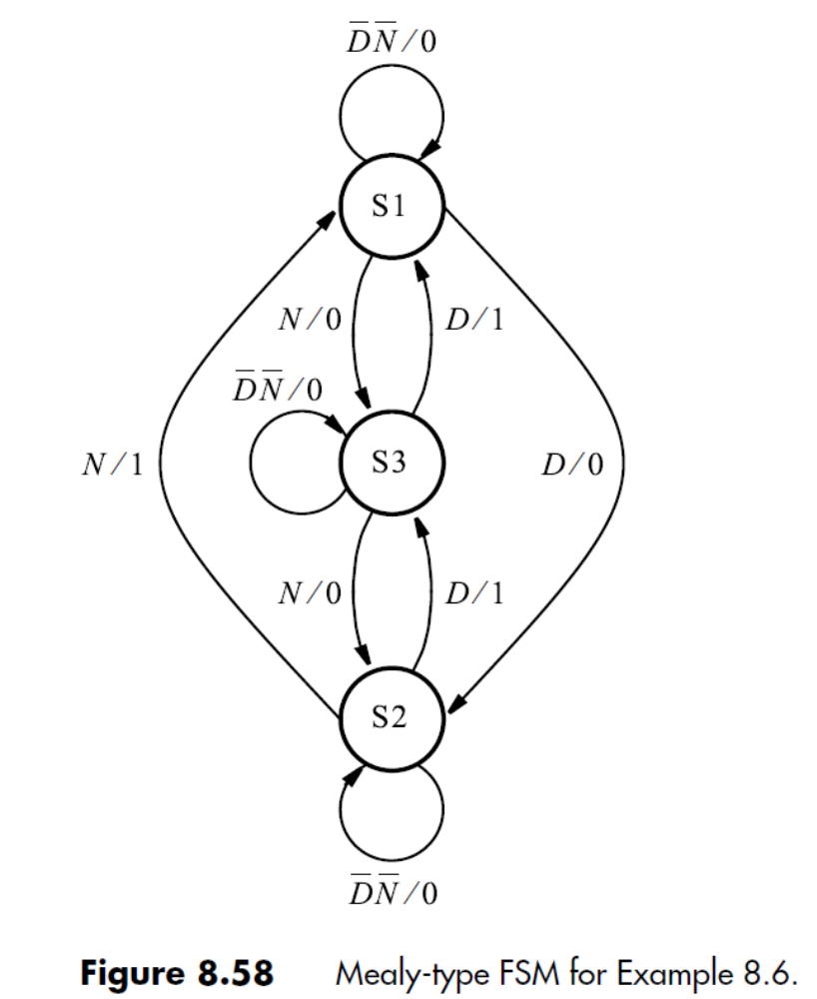

Solution:

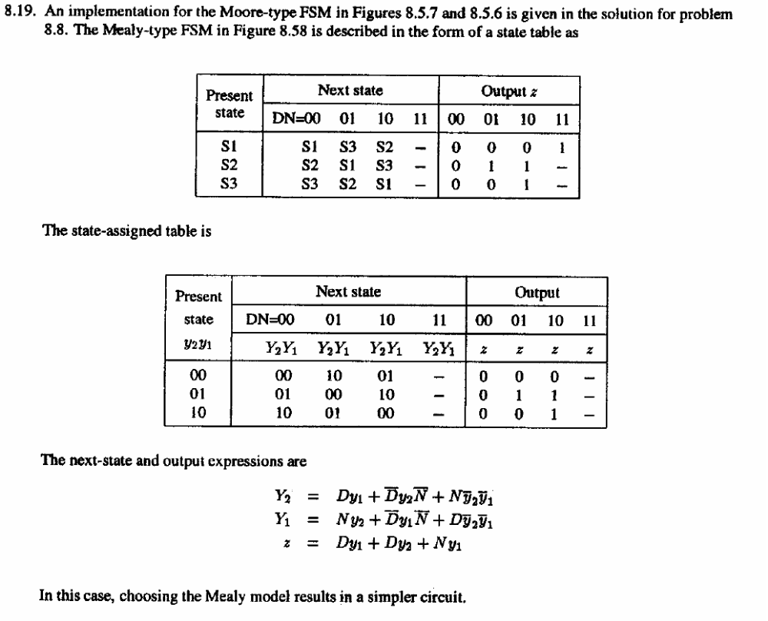

8.42

Question:

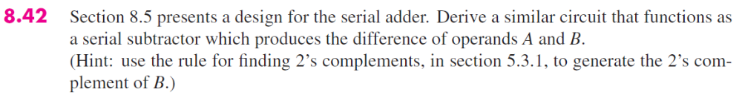

Section 8.5 is on page 519
Section 5.3.1 is on page 258

Solution:

